Eswar Boddepalli
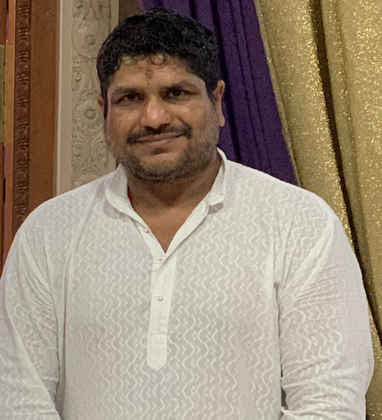

👤 About Me
I am a strategic technology and governance leader, with 24+ years of global experience transforming organizations and uplifting communities. As a longstanding HSCF volunteer and life member, my journey has been rooted in seva and guided by dharmic values. I am dedicated to strengthening our temple’s future through transparency, innovation, and inclusive leadership— qualities I will uphold as Vice President or any role I may need to serve.
🕯 My Vision To unite our diverse community through transparent governance, secure systems, and dharmic stewardship— laying a strong foundation for HSCF’s next generation.

“सत्येन धाययते पथिवीृ ” — By truth is the world sustained.
Respectfully,
Eswar Boddepalli
HSCF Trustee| Volunteer &
Seva Worker| 2026 Term-VP
732-423-1358| beshwar78@hotmail.com

Candidate Resume – Executive Committee President
(HSCF 2027 -2028 Term)

Executive Profile
- Strategic technology and governance leader with 24+ years of global experience, Leading enterprise transformation, audit, cybersecurity, infrastructure, finance modernization and organizational governance.
- Long-standing HSCF volunteer, Life Member and Trustee dedicated to transparent governance, dharmic stewardship, operational excellence and community service.
Leadership Vision
- To strengthen HSCF through transparent governance, financial stewardship, secure technology, disciplined execution and inclusive leadership while preserving our Hindu traditions for future generations.

Professional Experience
- Led global transformation programs for Fortune 500 organizations including Nike, Google, IBM, HP, Siemens, Nestlé, GM, Medtronic and Estée Lauder.
- Expertise in Internal Audit, Risk Management, Cybersecurity, ERP, Infrastructure, Financial Controls and Executive Governance.
- Managed global teams of 200+ professionals across multiple countries.
- Advisor to nonprofit and community organizations.

HSCF Service & Leadership (15+ Years)
- Thousands of volunteer hours supporting temple operations, canteen, infrastructure,religious events and community initiatives.
- Supported Murugan and Ayyappa sanctum projects, fundraising, facilities, Ratham activities and volunteer coordination.
- Built trust across Telugu, Tamil, Gujarati, Marathi, Malayali and North Indian communities through inclusive leadership.

Executive Committee Vice President (2026) – Key Accomplishments
- Modernized campus technology through secure fiber backbone and enterprise Wi-Fi.
- Strengthened physical security with CCTV optimization, storage upgrades and implementation of Sheriff's security recommendations.
- Initiated internal audit, governance, access management and cybersecurity improvements.
- Worked with Treasurer, Board and EC to improve financial systems, reporting, membership systems and operational controls.
- Developed strategic roadmaps for Audio/Video modernization, ERP readiness, security and digital governance.
- Supported cross-portfolio collaboration between Board, EC, Temple Office and volunteers.

Governance & Community Contributions
- Contributed to bylaw reform discussions focused on accountability, transparency and governance.
- Advocated structured planning, SWOT/RAID methodologies and long-term institutional sustainability.
- Mentored volunteers and promoted knowledge sharing, discipline and teamwork.
Records Maintained• Technology documentation• Security inventories • Vendor contacts • Governance documents • Audit observations • Infrastructure proposals • System access records • Transition documentation.

Transition Plan
- A structured transition package will be provided to the incoming Executive Committee Vice President and/or Board Vice Chair Shri Satish Mahajan Ji, as directed by the Board and Executive Committee. This includes documentation, administrative access inventories, vendor information, security systems, audit work, governance artifacts, project roadmaps and formal knowledge-transfer sessions to ensure continuity.

Why I Seek to Serve as President

I seek to serve with humility, integrity and accountability—bringing together governance, technology, finance, volunteers and our diverse community to strengthen HSCF for future generations. My objective is not merely to manage operations, but to build sustainable systems, empower volunteers and preserve our temple's mission through disciplined seva

