AJAY KUMAR CHERALA  Community Leader • Technology Leader | 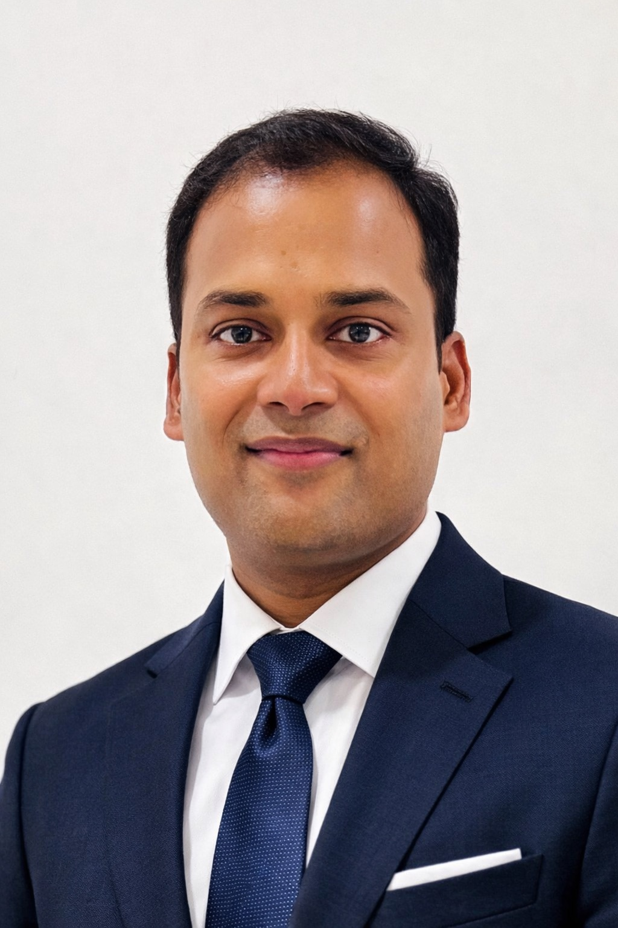
ABOUT ME
I am a technology leader with 20+ years of experience specializing in ERP systems implementation, support, and transformation. Throughout my career, I have worked with many Fortune 500 companies across the United States, helping organizations improve their systems, processes, and operations.
Beyond my professional career, I have been actively involved in nonprofit and community organizations, serving in leadership roles including President, Director, and Treasurer. I have led and supported numerous initiatives focused on strengthening communities, bringing people together, and creating meaningful opportunities for diverse communities across the USA.
VISION
To serve diverse communities with selflessness, compassion, integrity, and without expectation of personal gain, guided by the timeless values and principles of the Bhagavad Gita.
My vision is to promote unity, respect, inclusion, and service, bringing people from diverse backgrounds together while upholding strong values, ethical leadership, and a spirit of seva.
HSCF EXPERIENCE
• 10+ years of association with HSCF, with a strong commitment to the organization and its community.
• Actively participated in and supported numerous HSCF events and community initiatives.
• Served as a member of the HSCF Membership Committee, contributing to membership engagement and community outreach.
• Worked collaboratively with volunteers and community members to support HSCF programs and strengthen participation.
PROFESSIONAL PROFILE
ERP Systems Implementation & Support Specialist | 20+ Years of Experience | Experience Across Many Fortune 500 Companies in the USA
Nonprofit Leadership: President • Director • Treasurer | Community Initiatives & Volunteer Leadership
GUIDING PRINCIPLE
“Dharmo Rakshati Rakshitah”
धर्मो रक्षति रक्षितः
“Dharma protects those who protect and uphold Dharma.”
CONTACT
Ajay Kumar Cherala
Cell: +1 903-274-5618
Email: ajaycherala99@gmail.com

